# **E Commerce application**

Create E Commerce application using following details provided.

* Default Page will be ProductList.aspx.
* User can perform following activities without Login
  + User can Search for products
  + User can view Product List & Details
  + User can add Products to Cart
* For Checkout, the user must be redirected to the Login Page.
* New User Registration link should be available on the Login page.
* Forget Password link should be available on the Login Page
* If items were added by the logged in user, added items must be preserved and displayed when the user logged in again

**1) Login.aspx**

Login.aspx must comprise of following fields

* Username
* Password
* Link for Forgot Password
* Login & Cancel Button

# Validations

* Login & Password must be a required field, use client side validation
* On click on Cancel, Login & Password text box should be cleared
* Validation for Incorrect login & password.

**2) Registration.aspx**

Registration.aspx must comprise of following fields

* User Name/Email
* Password
* Confirm Password
* First Name
* Last Name
* DOB
* Shipping Address (Address, City, State, zip- Zip code must be of 6 characters)
* Billing Address (Address, City, State, zip- Zip code must be of 6 characters)
* Phone #

# Validations

* The password & Confirm password must match (Use Compare validation).
* Passwords must have at least one non-letter or digit character. (Client side validation).
* Passwords must have at least one digit ('0'-'9').
* Passwords must have at least one uppercase ('A'-'Z').
* The password must be stored encrypted value into the database.
* Check for existing user/Email into database- duplicate user name should not allow.
* User Name/Email/Password/Confirm Password must be a required field.
* DOB must be less than today's date, must be a required field.
* The phone number must be at least of 10 characters.
* Use validation summary to display error messages.
* Email, check for valid email format.

**3) ProductList.aspx -**

List view of products. Listing page should comprise of

* Product Name (Link to product detail page)
* Product SKU
* Product Image
* Product short description
* Product Price
* Add to Cart Button (If user click "Add to Cart" button multiple time, Product is already available into cart, add +1 quantity)

# Validation

* The user can search by Product Name, SKU, based on the search result Product listing should be generated.
* Search text must be at least 3 characters or more.
* Bring all the matching search results (use like %% condition for search result)
* Implement paging if a search result is beyond 15 records.
* On click of Add to Cart Button, one entry will be done into Order table.
* If User is already having an active Order (Order Status = Not Paid), Add items to active order. Instead of creating a new order.

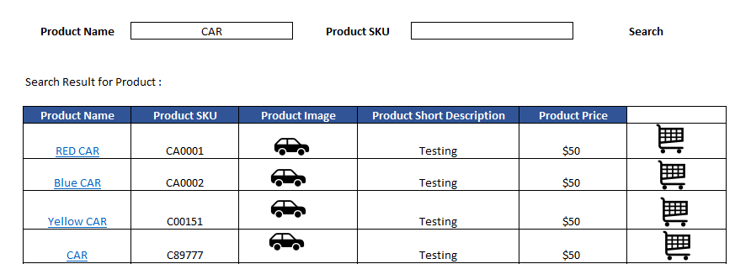

**4) ProductDetails.aspx**

Product detail page comprises of

* Product Name
* Product SKU
* Product Long Description
* Product Price
* Product images (Multiple images)
* Product Quantity (user can add/remove +/- quantity)
* Add to Cart Button (If user click "Add to Cart" button multiple time, Product is already available into cart, add +1 quantity)

# Validations

**5) ShoppingCart.aspx --Details of card items**

* Product Name
* Product Unit (User can add/delete quantity)
* Unit Price
* Total
* Grand Total
* Shipping & Billing address details (User can have multiple Shipping/Billing Address)
* Button for Checkout -- On click on Checkout User should be redirected to ShoppingCartActions.aspx

# Validations

* For Active Order, Product wise single entry will be done in the database.If the user is adding multiple QTY, QTY field will be updated respectively, while adding/removing QTY
  + For Ex.Adding an Item Scenario: if order table is having Product Blue Cart = QTY = 1, the user is adding 1 more QTY, database should have QTY = 2
  + For Ex.Removing an Item Scenario: if order table is having Product Blue Cart = QTY = 2, user is removing 1 QTY, the database should have QTY = 1
  + If Current QTY = 1, the user is removing QTY from Cart, entry will be deleted from the database.

**6) ShoppingCartActions.aspx**

* Display Cart Item as read only
* Proceed to Checkout button - On click of this button, Mark Order status as Paid.

**7) OrderHistory.aspx**

User can view the history of already processed orders

* Product Name
* Product Unit (User can add/delete quantity)
* Unit Price
* Total
* Grand Total
* Shipping & Billing address details
* Status of Order (paid/ Not Paid)